**UNIVERSITY OF JAFFNA, SRI LANKA**

**Faculty of Engineering**



ACADEMIC CALENDAR MANAGEMENT SYSTEM

GitHub : https://github.com/IsuruAkalanka/academic_calendar

by

CUMARANATHUNGA P.I.A. (2018/E/022)

ERANDA A.H. (2018/E/031)

PERERA U.L.K.K. (2018/E/091)

SACHINTHA D.C. (2018/E/104)

SATHURJAN J. (2018/E/108)

A project proposal submitted to the

Department of Computer Engineering

In partial fulfillment of the requirements for the

course module EC6060 software engineering for the

Degree of Bachelor of Science of Engineering

29th July 2022

**Introduction and Cover Letter**

Dr. S. Thananjeyan

Senior Lecturer

Department of Electrical and Electronic Engineering

Faculty of Engineering

University of Jaffna

Kavindya Perera

Leader – Team 01

Department of Computer Engineering

Faculty of Engineering

University of Jaffna

08th June 2022

Dear Dr. Thananjeyan,

Please find enclosed our detailed software proposal for your kind consideration.

At Department of Computer Engineering, Faculty of Engineering, University of Jaffna we are aware that creating **Academic Calendar Management System** software takes a mixture of technical excellence and clear communication and our team hires only the very best to ensure you receive both. We know that every client is unique and we strive to deliver an individual, innovative and affordable proposal and to follow it through with an outstanding delivery which is both on time and within budget.

We have more development in this area and our previous developments include theatre booking system in software construction, database management system projects

Please let us know if you would like to get in touch with our existing clients from whom you will receive nothing but positive endorsements. You may also wish to review our previous work and learn more about our development skills and knowledge.

We also pride ourselves on our after-sales client-care including our guarantees, staff-training and onsite and offsite support.

Finally, we realize that you are very busy and wanted to thank you in advance for your time spent reviewing our proposal.

Yours Truly,

Kavindya Perera

Computer Department

Faculty of Engineering, University of Jaffna.

1. **CUSTOMER PROBLEM STATEMENT**
   1. **Problem Statement**

**Executive Summary**

The modern world has been irrevocably shaped by technology and for good reason. Many long-standing problems in industries can be solved with the right program. It's not enough to simply use pre-existing solutions, however.

**Create Academic calendar management system**

After a thorough but efficient preparation period, our team finally decided to create an academic calendar management system for AR.

We are expecting to give our main focus specially on the semester periods, exam periods, holiday periods, course registration periods, and exam registration periods. The resulting software will achieve:

* Clear visualization of when the semester begins/ ends
* Clear visualization of exam periods
* Clear visualization of holiday periods
* Clear visualization of course registration open/close date and the duration
* Clear visualization of exam registration open/close date and the duration
* Feature to add/update/delete all the above periods

**Integrate MS Teams and Trello**

With the coordination with Dr. Thananjeyan, we got the use of both MS Teams and Trello for this project.

We will achieve the goals listed above by utilizing agile methodology. This process allows us to clearly visualize the academic calendar and edit the particular durations.

Up to now, planning we decided to complete this project within ten-week time.

**Technical obstacles**

**Technical skills**

For this project we have to work with a particular tech stack which every member of the team might not be familiar with. Being familiar with the stack and being able to develop the requirements can be a bit of a challenge under the current deadlines.

**Integration Issues**

It might be a challenge to integrate what we are making with tools currently existing. We have to find ways to make our product compatible using APIs so the app can be used in other products as an external module.

**Industry and market risks**

Following are some of the applications already exist for calendar management purpose

* Infinity
* Google Calendar
* Apple Calendar
* Outlook Calendar
* Fantastical 2

Most of these providers provide following features to the user through their application

* Schedule creation and management
* Customizable views and layouts
* Necessary integrations with other apps
* Shareable appointments or entire calendars, event
* User-friendly interface

While these applications provide the above features, they are not meant for a task like academic semester scheduling. So, in this project we are focusing on that particular area. Possibility of user’s current requirement change or another potential solution from the competitors to match the user requirements are potential risks.

1. **SYSTEM OF REQUIREMENTS**

|  |  |  |
| --- | --- | --- |
| IDENTIFIER | PRIORITY WEIGHT | REQUIREMENTS |
| REQ-1 | 10 | Basic CRUD operations for event managing |
| REQ-2 | 10 | System should allow Administrative/ Staff/ All Undergraduates to view the summary |
| REQ-3 | 8 | Filter the calendar based on the user preferences |
| REQ-4 | 10 | System should allow API for other systems to use notifications system |
| REQ-5 | 7 | Should send notifications automatically |
| REQ-6 | 9 | Should expose APIs for other users to use |
| REQ-7 | 10 | Login functionality for authorized users and API users |

* 1. **Enumerated Functional Requirements**
  2. **Enumerated Non-Functional Requirements**

|  |  |  |
| --- | --- | --- |
| IDENTIFIER | PRIORITY WEIGHT | REQUIREMNTS |
| REQ-8 | 10 | As a system, only authorized users have the eligibility for the system |
| REQ-9 | 6 | As s system should work properly under any traffic condition |
| REQ-10 | 6 | As a system, it system should be responsive and user friendly |
| REQ-11 | 7 | As a system, it should be optimized and should worth for the hosting costs. |

* 1. **User Interface Requirements**

|  |  |  |
| --- | --- | --- |
| Identifier | Priority Weight | Requirements |
| REQ- 12 | 10 | Landing page |
| REQ -13 | 10 | Selecting a date (8th of August, 2022) |
| REQ -14 | 10 | Selecting an event (Click Vacation) |
| REQ -15 | 10 | Saving updated details (Click Save) |
| REQ -16 | 10 | Updated Calendar |

1. **FUNCTIONAL REQUIREMENT SPECIFICATIONS**
   1. **Actors and Goals**

|  |  |  |
| --- | --- | --- |
| ACTOR | ACTOR’S GOAL | USE CASE NAME |
| AR System Admin | To do all the operations CRUD for the events | Event handling (UC - 1) |
| Staff/undergraduates | To view the summary | View the Summary (UC - 2) |
| IT Management | To look in to System Faults | System management (UC - 3) |
| API users | To send notifications to selected group of students of staff | Notification sending (UC - 4) |

* 1. **Use cases**
     1. **Casual Description**

**UC#1 Event Handling**

Here AR System Admin is having all the responsibility to handle all the events. He is responsible for creating, viewing, updating and deleting all the events

1. Semester start/ end dates
2. Semester start/ close Registration dates
3. Holidays
4. Dead Weeks
5. Mid/ End Semester Examinations
6. Exam Registrations

**UC#2 View the Summary**

In the system all the Undergraduates as well as all the Staff are having the access to view the Summary**.**

**UC#3 System Management**

If any System fault occurs, IT Management should look in to the System faults and do the needful.

**UC#4 Send Alerts/ Notifications**

AR System Admin should allow API for other systems to use notifications system.

* + 1. 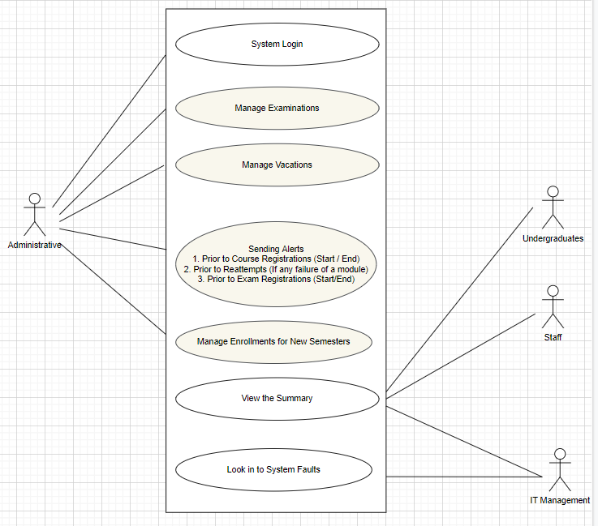Use Case Diagram

1. **Traceability Matrix**

The below table depicts the mapping of the various requirements of our system with the use cases defined previously. The requirements are given based on a scale from 1 to 10, 1 being the lowest priority and 10 being the highest priority.

|  |  |  |  |  |  |
| --- | --- | --- | --- | --- | --- |
| REQ’T | PW | UC1 | UC2 | UC3 | UC4 |
| REQ-1 | 10 | x |  |  |  |
| REQ-2 | 10 |  | x |  |  |
| REQ-3 | 8 |  | x |  |  |
| REQ-4 | 10 | x |  |  |  |
| REQ-5 | 7 |  |  |  | x |
| REQ-6 | 9 |  |  |  |  |
| REQ-7 | 10 | x |  | x | x |
| REQ-8 | 10 |  |  | x | x |
| REQ-9 | 6 |  |  |  |  |
| REQ-10 | 6 |  |  |  |  |
| REQ-11 | 7 |  |  |  |  |
| Max Weight | 10 |  |  |  |  |
| Total Weights |  |  |  |  |  |

1. **Fully Dressed Description**

**Use Case UC#1Event Handling**

Related Requirements: REQ -1, REQ -4, REQ -7

Initiating Actor: AR System Admin

Actor’s Goal: To handle events in a proper manner

Participating Actors: - AR System Admin

Precondition: System should be active and running, AR System Admin should have established connection with the System

Postcondition: AR System Admin can do any required operations for events

Failed and condition: AR System Admin should have to wait for some more time and try again, for the requirements

**Use Case UC#2View the Summary**

Related Requirements REQ -2, REQ -3

Initiating Actor: AR System Admin, Staff, Undergraduates

Actor’s Goal: To view the summary to schedule their curriculum

Participating Actors: AR System Admin, Staff, Undergraduates

Precondition: System should be active and running, Users should have established connection with the System

Postcondition: Users can view the Summary

Failed and condition: Try again later again, for the requirements

**Use Case UC#3: System Management**

Related Requirements: REQ -7, REQ -8

Initiating Actor: AR System Admin

Actor’s Goal: To handle events in a proper manner

Participating Actors: - IT management

Precondition: System should be active and running

IT management should have established connection with the System

Postcondition: IT management can do any required operations for events

Failed and condition: IT management should take necessary actions to make the system up and running again

**Use Case UC#4: Send Alerts/ Notifications**

Related Requirements: REQ -4, REQ -7, REQ -8

Initiating Actor: AR System Admin, API users

Actor’s Goal: To handle events in a proper manner

Participating Actors: - API users, Students and staff

Precondition: System should be active and running

AR System Admin or API users should have established connection with the System and authenticated

Postcondition: AR System Admin can do any required operations for events

Failed and condition: Wait for some time and try again.

* 1. **Sequence Diagrams**

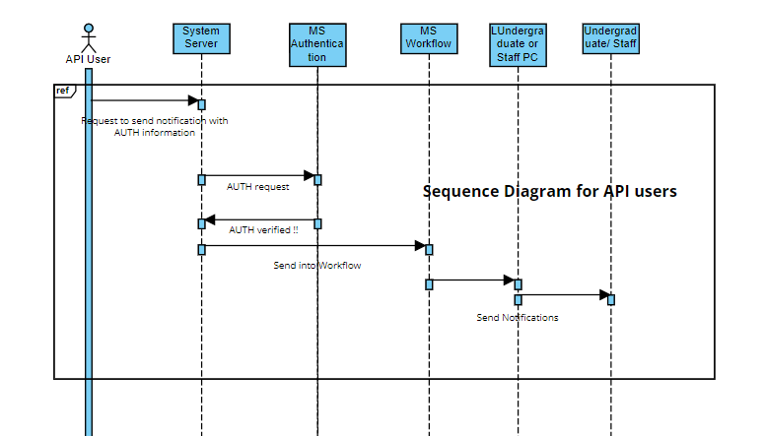

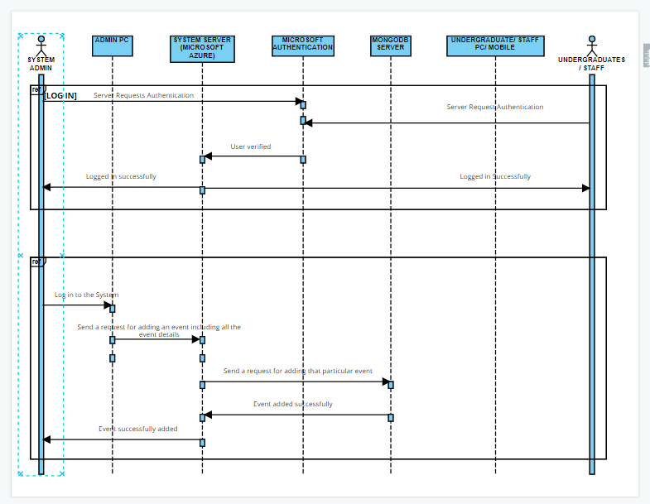Figure 1 : sequence diagram for api users

Figure 2 : sequence diagram for sign in and event scheduling(ADD)

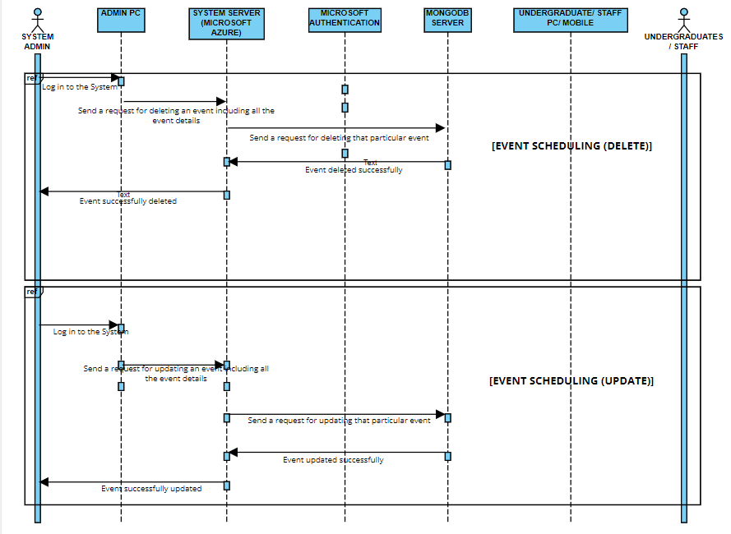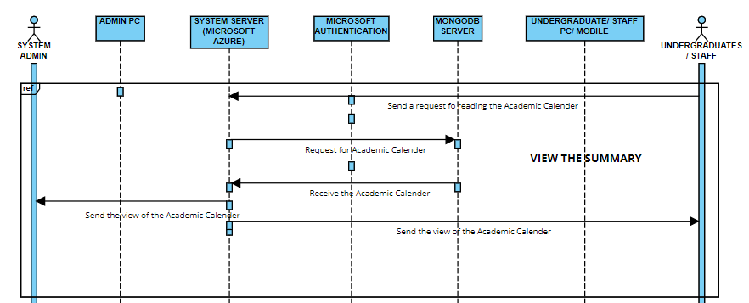

Figure 1 : sequence diagram for event scheduling(delete and update)

Figure 2 : sequence diagram for view the summary

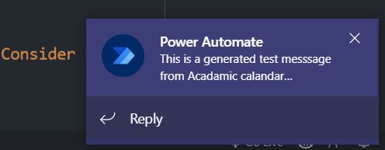**TEST CASE RESULTS**

